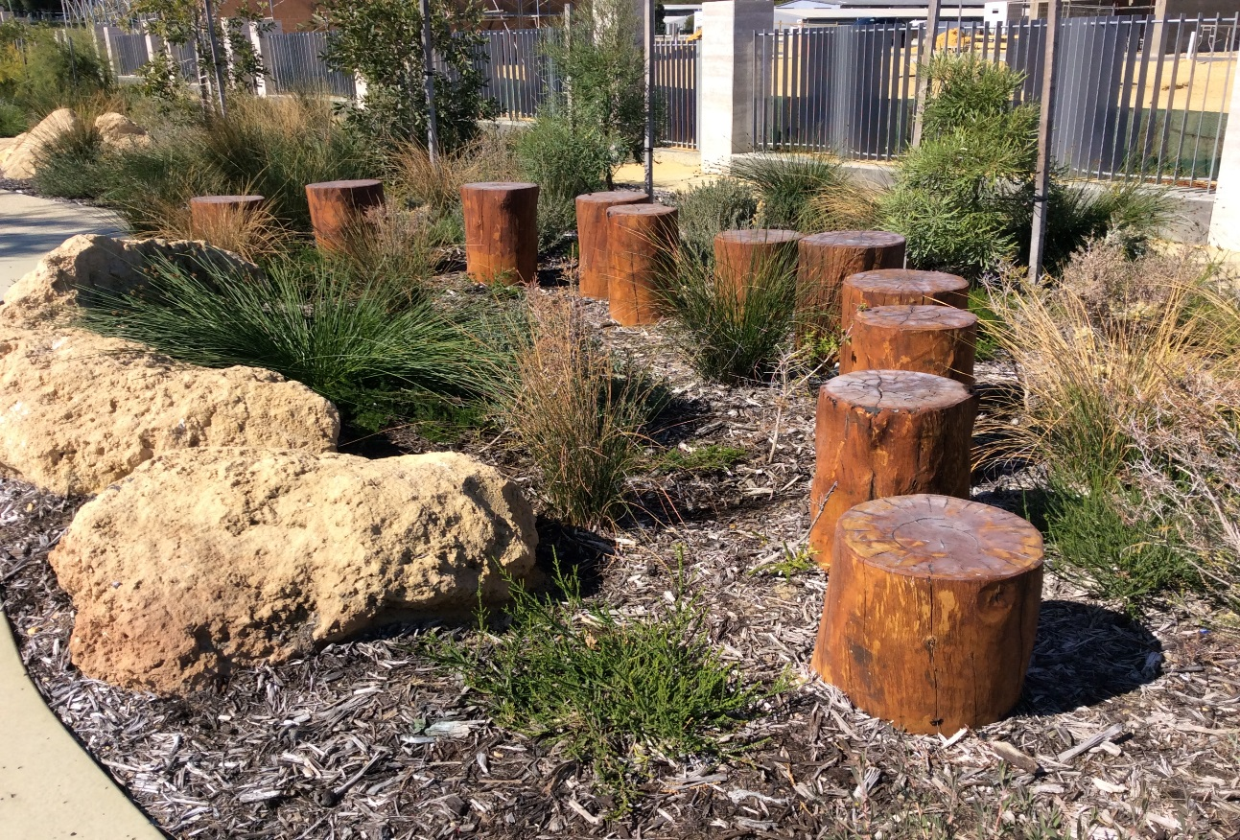

**Naturally Kids Play Workshop**

**Who should attend?**

* Local Government :
  + Parks Supervisors
  + Maintenance Staff
  + Landscape Designers
  + Risk Managers
* Early Childhood & Children’s Services
  + Students
  + Early Childhood Professionals
  + Child Care Licensing Officers
* Primary Schools:
  + Principals
  + P & C’s
  + Grounds Maintenance Staff
* Landscape Architects and Designers
* Agencies providing playgrounds
* Health Promotion Officers and Health professionals

Equipment manufacturers, designers and representatives.

Are you interested in finding our more about Natural Playspaces? Not sure where to start? Join Play @ Kidsafe WA in this workshop looking at the **benefits of natural play**, how to make them **inclusive**, **accessible** and how they relate to the Australian Standards for Playgrounds

We will show you examples to inspire you to create safe, stimulating, and cost-effective outdoor environments for children

**When: 24 February 2022, 9am -11.30am**

**Where: David Grays Arena (Peel Thunder), Dower St, Mandurah WA 6210**

**Cost: Free – morning tea included**

**RSVP: 17 February 2022 to** [**cdo@mandurah.wa.gov.au**](mailto:cdo@mandurah.wa.gov.au) **or register here;**

[**https://www.eventbrite.com.au/e/naturally-kids-play-workshop-tickets-243339524067**](https://www.eventbrite.com.au/e/naturally-kids-play-workshop-tickets-243339524067)

