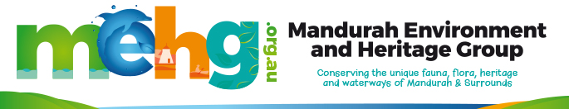
MEMBERSHIP

About our membership
MEHG offers two types of membership, individual for $10 per annum and family for $20 per annum. The fee is payable on 1st July each year.
Membership gives you the right to attend committee meetings and be involved in planning and implementing projects (both categories of membership provides one voting right).
Being a member also means you are automatically covered by our insurance when attending or undertaking a MEHG organised activity.

Application Form
I would like to become a member of Mandurah Environment & Heritage Group, or renew my membership. Membership type Individual $10 ☐ Family $20☐

I agree to abide by the Rules of Mandurah Environment & Heritage Group as per link below
https://mehg.org.au/wp-content/uploads/MEHG-Rules-of-the-Association.pdf

Name/s | Click or tap here to enter text.
Address | Click or tap here to enter text.
Phone | Click or tap here to enter text.
Email | Click or tap here to enter text.
Date | Click or tap here to enter text.

Please pay the relevant membership fee to Mandurah Environment & Heritage Group Inc.
BSB: 633 000
ACC: 155 720 881

Do you need a receipt? Yes☐ No☐

Scan and send your membership application to info@mehg.org.au or bring it to one of our meetings that are held on the third Thursday of the month at 5:00pm at The Shed at the rear of Peel-Harvey Catchment Council, 58 Sutton Street, Mandurah 6210

Optional: Please tell us what you’re most interested in.
Click or tap here to enter text.

