Clean Up Peel Waterways Registration Form
It is with pleasure that Friends of Rivers, Peel and the Peel Harvey Catchment Council invite you to participate in the annual Clean Up Peel Waterways event during the month of March 2020.
We will be promoting the Clean Up Month via social media, email and other local media. Please provide your community group details below. This information will be included in the promotional advertisements to ensure community members are able to contact the appropriate people in their area to take part in the clean-up events.
Return your completed form to Jessie Fenelon at support1@peel-harvey.org.au by 31 January 2020.
Please remember to register your site with Clean Up Australia so that your equipment arrives in time https://www.cleanupaustraliaday.org.au Clean Up Australia also provides public liability insurance, so this step is important and necessary for a successful clean-up event.

Organisation / Community Group / Business Name
Contact Person
Mobile
Email
Event Address
Meeting Point
Event Date
Event Start and End Time
Is your event an open or closed event?
Event Activity Brief (Max 30 words)
(Example description please delete and add your own)
Volunteers are welcome to help us clean up Samphire Cove’s parks, foreshore and road verges. Bags supplied. Morning tea for volunteers from 11am.

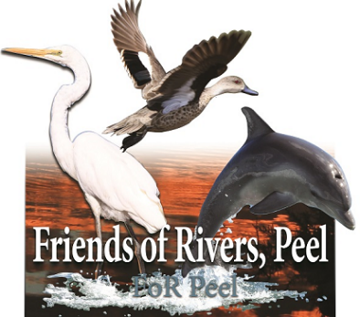

We acknowledge the Noongar people as Traditional Custodians of this land and pay our respects to all Elders past and present

