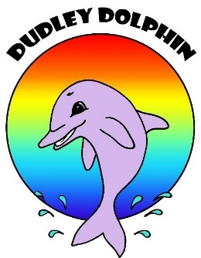
Clean Up the Peel 2021
Registration Form
It is with pleasure that Friends of Rivers, Peel and the Peel-Harvey
Catchment Council invite you to participate in the annual March Clean-Up.
We will be promoting Clean Up the Peel 2021 via social media, email and other local media. Please provide your community group details below. This information will be included in the promotional advertisements to ensure community members are able to contact the appropriate people in their area to take part in the clean-up events.
Please remember to register your site with Clean Up Australia as soon as you can so that your equipment arrives in time - www.cleanupaustraliaday.org.au
Clean Up Australia also provides public liability insurance so this is a very important and necessary step for your event.
Community Group / Organisation /
Business Name
Contact Person
Mobile Number
Email Address
Event Address
Meeting Point
Event Date
Start Time and End Time
Is your event an open or closed event?
Event Activity Brief (Max 30 words)
(Example description - please delete and add your own)
Volunteers welcome to clean up reserve and adjacent areas, including the river. Own kayak needed for river clean. Land area on foot. Bags provided. Volunteers’ morning tea from 11am.
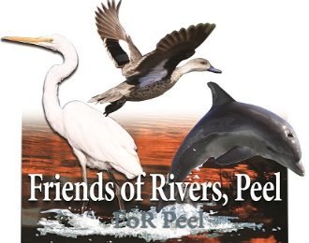 |  | 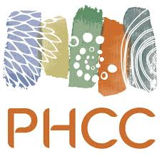
We acknowledge the Noongar people as Traditional Custodians of this land and pay our respects to all Elders past and present

